|  |  |
| --- | --- |
| **Student Name** | **Arun Adhikari** |
| **SRN No** | 202100406 |
| **Roll No** | 38 |
| **Program** | Computer Engg |
| **Year** | Third Year |
| **Division** | G3 |
| **Subject** | Computer Network Laboratory (BTECCE21506) |
| **Assignment No** | 10 |

**Configuration of FTP server on windows**

A **File Transfer Protocol (FTP)** server is a network protocol that enables the transfer of files between client and server over a TCP-based network such as the internet or an intranet. FTP servers are used to store, share, and manage files across different systems. On **Windows**, you can set up an FTP server to allow users to upload, download, or manage files remotely. FTP provides a secure and reliable means of file transfer and is commonly used in both personal and enterprise environments.

### ****Features of FTP Server on Windows:****

**User Authentication and Access Control**: FTP allows secure authentication with user credentials, enabling administrators to define access levels for different users.

**Data Encryption**: While FTP in its original form does not provide encryption, **FTPS** (FTP Secure) offers a way to secure the transmission of files using SSL/TLS.

**Passive and Active Modes**: FTP supports both active and passive modes, ensuring compatibility with various network configurations like firewalls and NAT.

**Remote File Management**: Users can upload, download, delete, or rename files remotely, allowing for flexible file management.

**Logging and Monitoring**: FTP servers on Windows come with built-in logging features, allowing administrators to monitor file transfers and user activities.

**Directory Permissions**: Administrators can set specific permissions for directories (read, write, execute), enabling fine control over file access.

**Multi-Session Capability**: FTP servers can handle multiple users and file transfers simultaneously.

**Anonymous Access**: You can configure anonymous access for users without credentials, allowing public access to specific files.

**Third-Party Integration**: Windows FTP servers can integrate with third-party software for enhanced security, automation, or analytics.

### ****Topology of FTP Server:****

#### ****Basic FTP Server Topology:****

**FTP Client**: The device (computer, mobile, etc.) that initiates the connection and requests files from the FTP server. Common clients include FileZilla, WinSCP, and built-in FTP tools on OS.

**FTP Server**: The central system where the files are stored, managed, and served to clients. In Windows, **IIS (Internet Information Services)** can be used to set up the FTP server.

**Firewall/NAT**: Security systems may be in place to control and filter FTP traffic between the client and server. Passive mode FTP ensures smooth operation across these security layers.

**Internal/External Networks**: The server could be part of a private intranet or publicly accessible over the internet.

#### ****Advanced Topology with FTPS****:

**FTP Server with SSL/TLS**: For secured data transfer, the FTP server can be configured with **FTPS**, where certificates are used to encrypt data.

**VPN Tunnel**: Sometimes, for added security, a VPN tunnel is established between the client and the FTP server.

#### ****Basic FTP Server Configuration in Windows****:

**Install IIS (Internet Information Services)**:

* + Go to Control Panel > Programs > Turn Windows Features on or off.
  + Select **Internet Information Services** and expand it.
  + Check **FTP Server** options.
  + Click OK to install.

**Configure FTP Site**:

* + Open **IIS Manager** from the start menu.
  + Right-click on **Sites** and select **Add FTP Site**.
  + Configure the site’s **IP address**, **port**, and **physical folder** where files are stored.
  + Set **authentication** (Basic/Anonymous) and **authorization** (Read/Write permissions).

**Open Ports**:

* + Open the firewall to allow **port 21** (default FTP port) and any necessary data channel ports for passive mode.

**Test the Connection**:

* + Use any FTP client (e.g., FileZilla) to connect to the server by entering the IP, port, and credentials.

**OUTPUT :-**

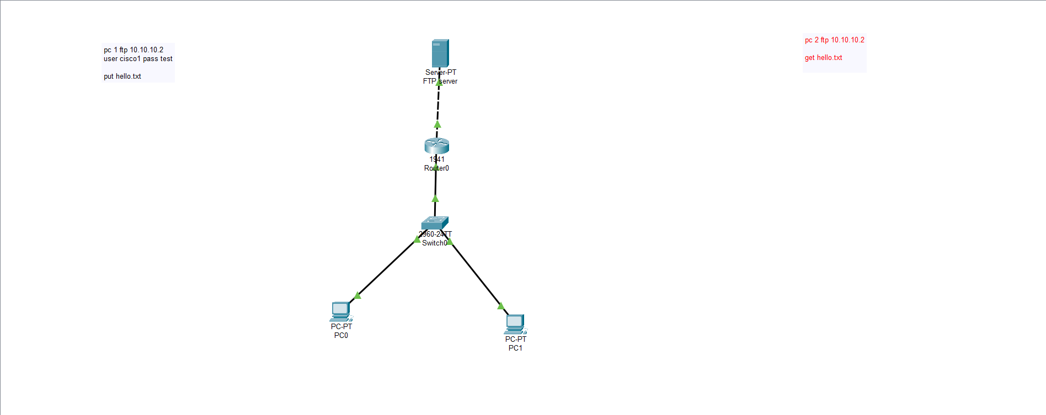

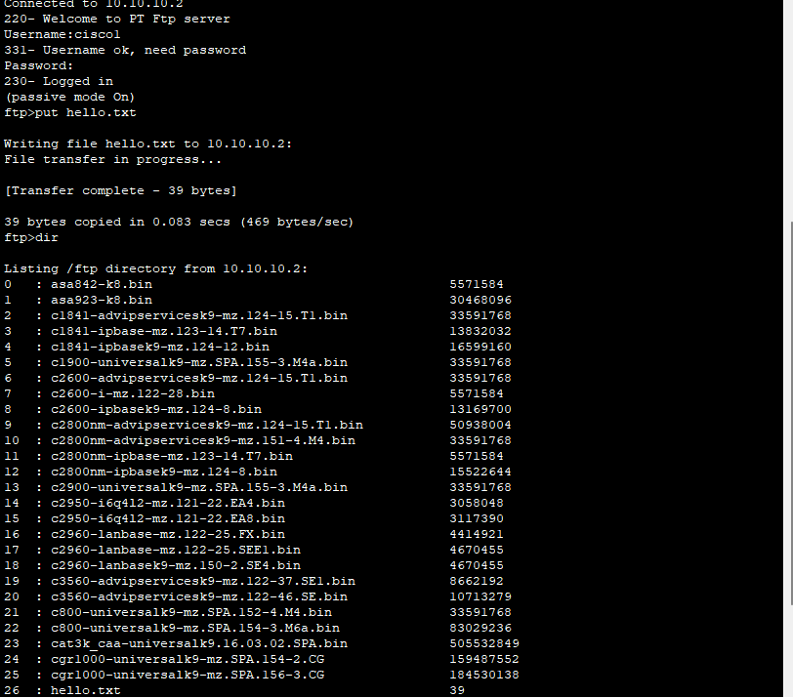

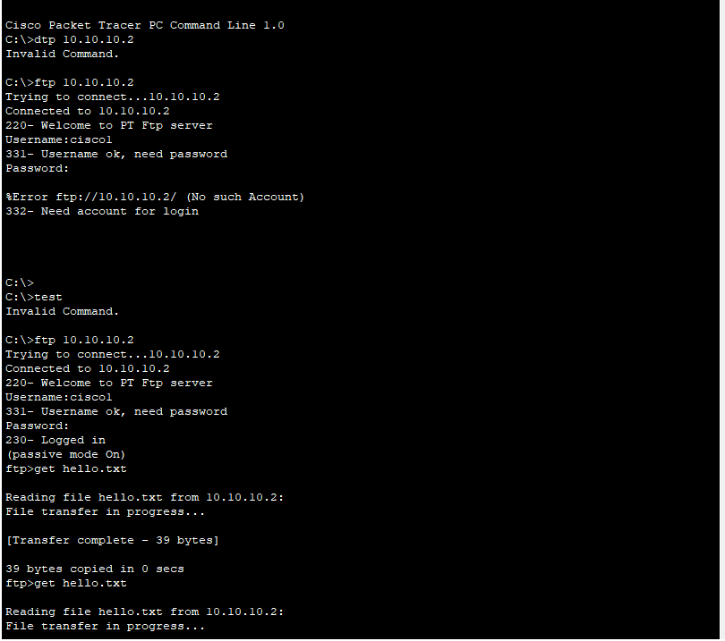

**Conclusion**

Configuring an FTP server on Windows is straightforward and offers powerful features for file sharing, access control, and secure data transmission. FTP's flexibility makes it useful for both individual users and businesses, and with additional security measures like FTPS, it can be adapted to suit modern security requirements. Proper configuration, including user permissions and network settings, ensures efficient file transfer while maintaining a secure environment.